1. **Agenda:**
   1. How to send with async call.
2. 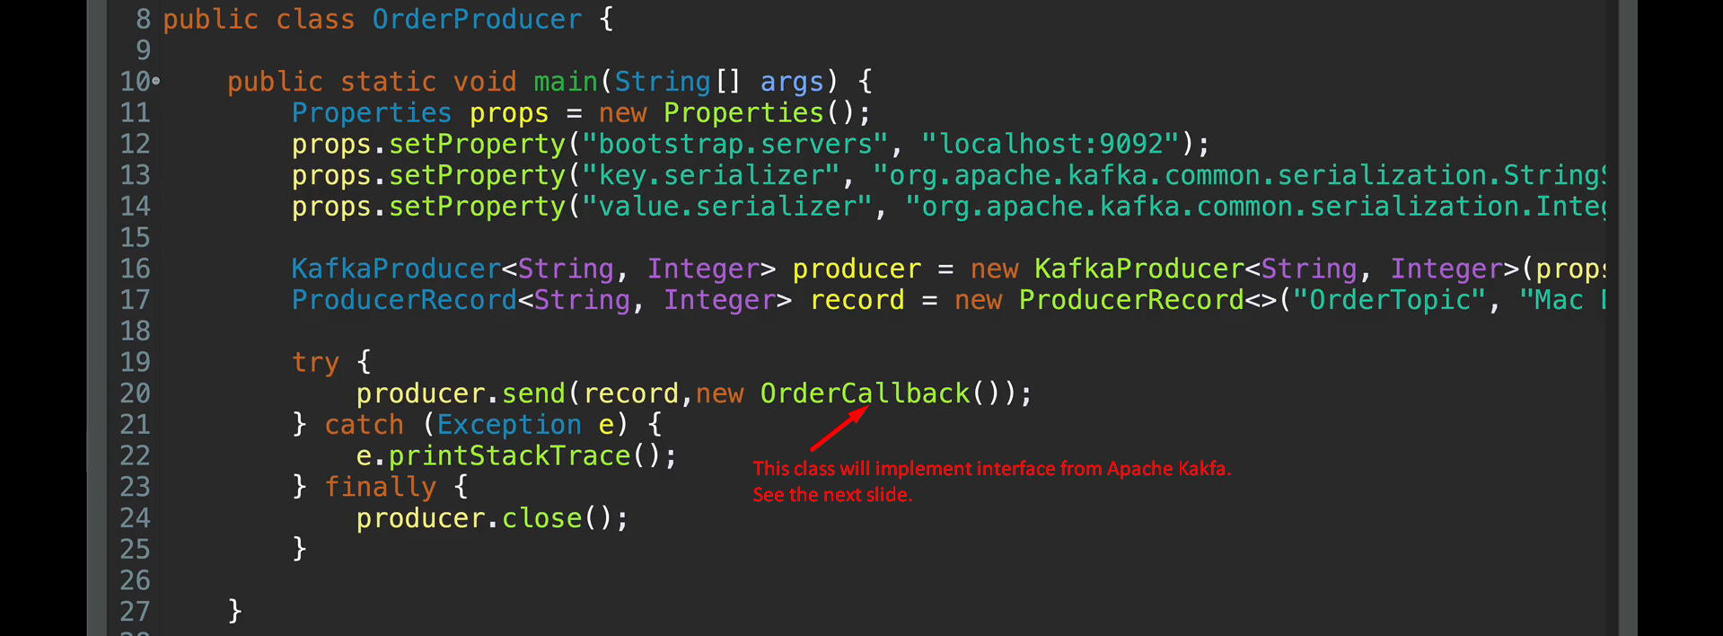
3. Text

   Description automatically generated